REPORTING SERVICES USING ALWAYSON AVAILABILITY GROUP
https://jbswiki.com/2017/09/06/reporting-services-using-alwayson-availability-group/
Author: Vivek Janakiraman

Environment
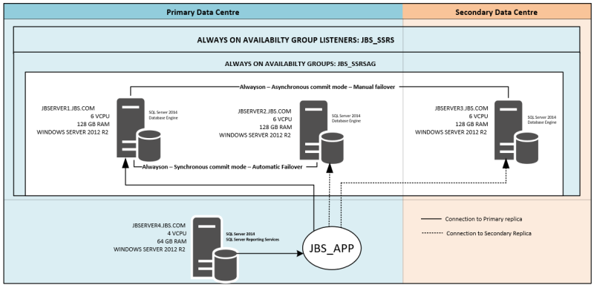
->SQL Server Reporting Services present in JBSERVER4 is configured using Database Server JBSERVER1 initially.
-> SQL Server Reporting Services databases are later placed on the Availability Group JBS_SSRSAG.
-> Database [ReportServerTempDB] recovery model will be changed to Full from Simple.
-> Adding the [ReportServer] and [ReportServerTempDB] database to the Availability group JB_SSRSAG.
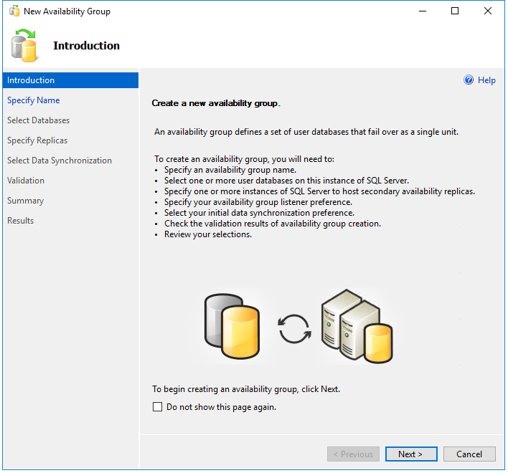
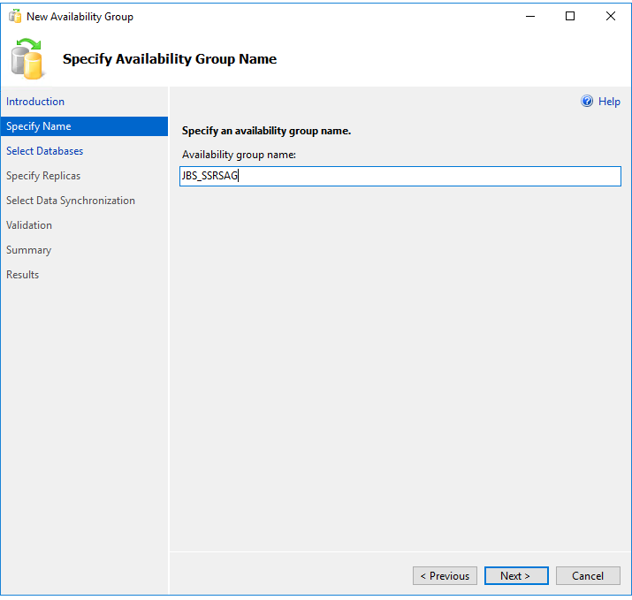
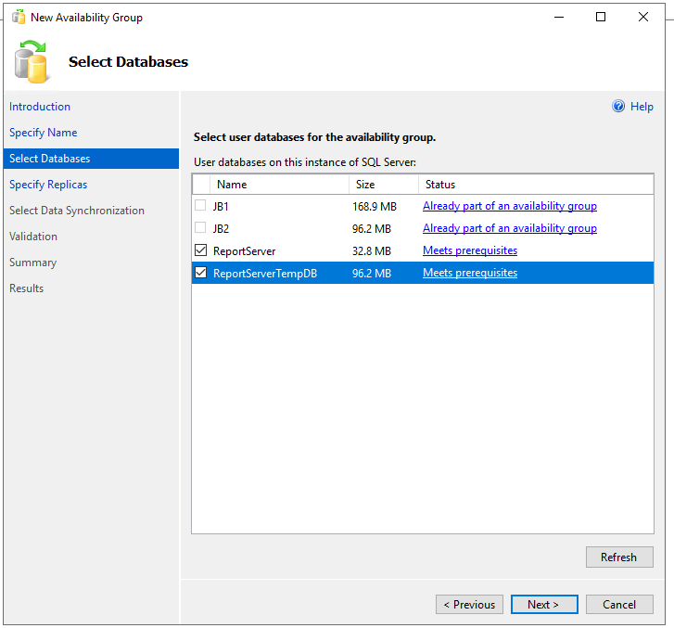
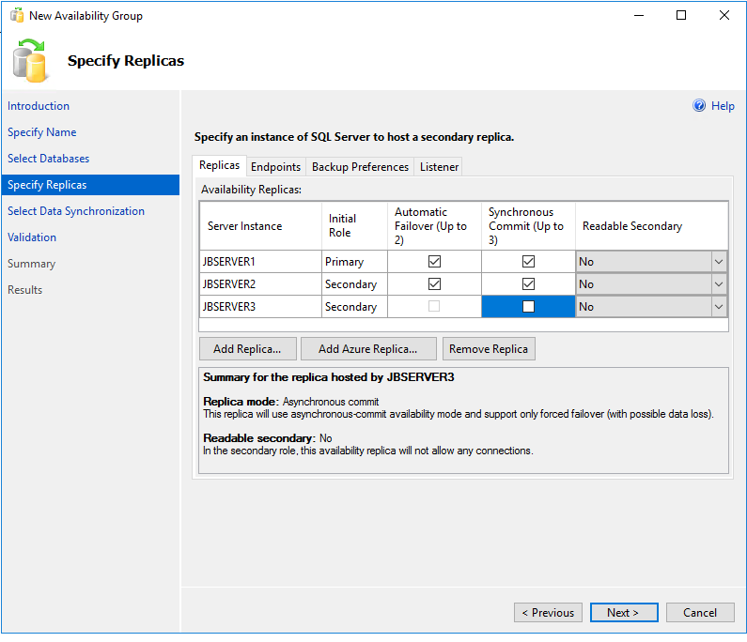
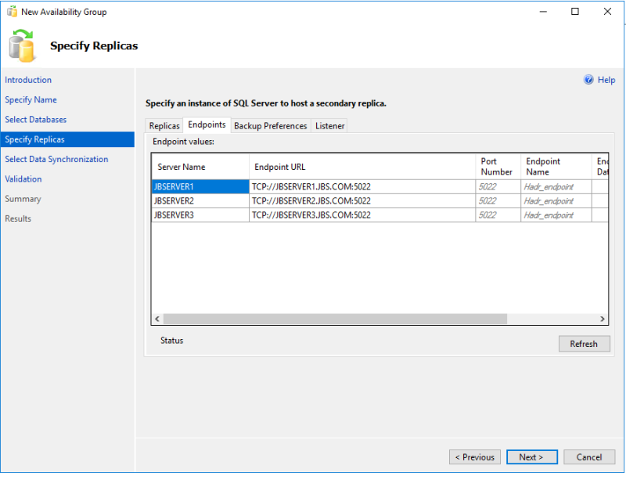
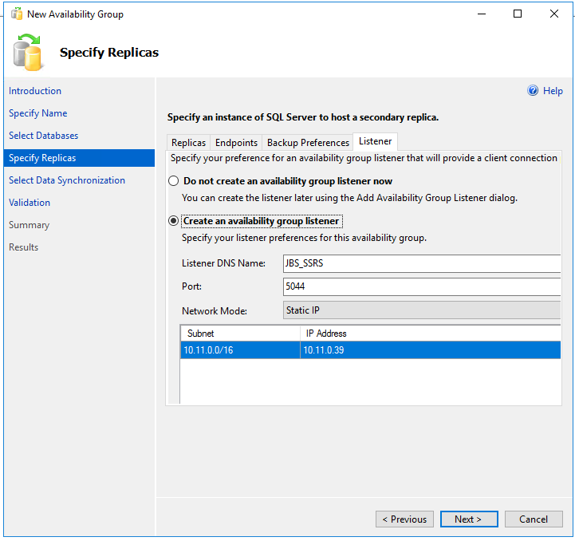
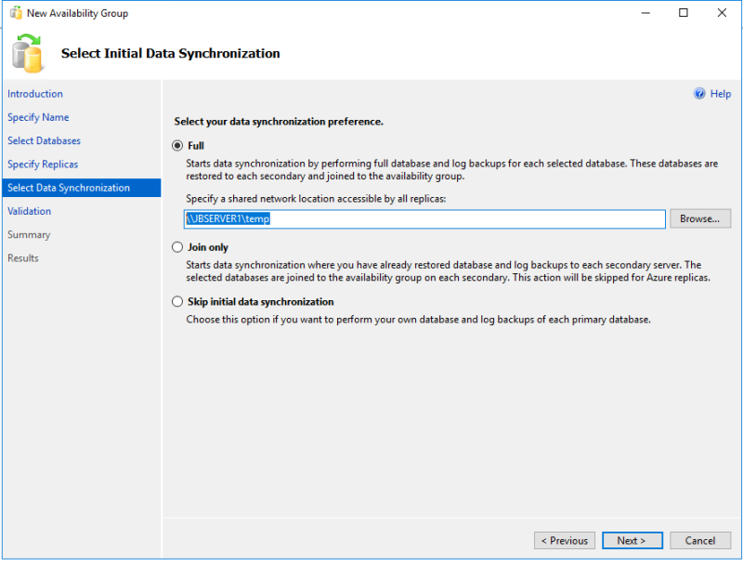
REPORT THIS AD
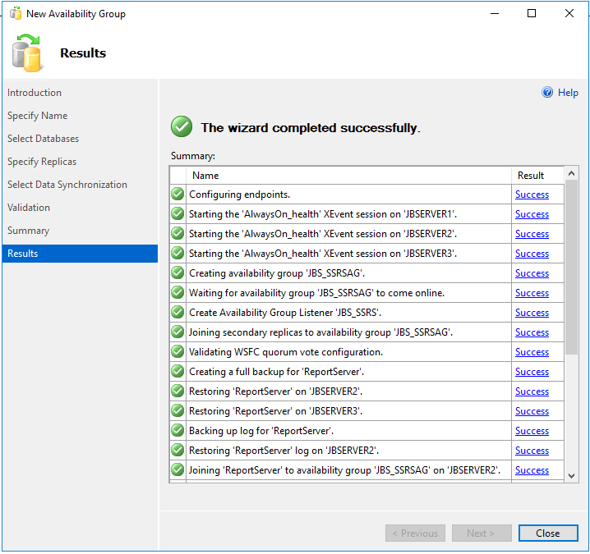
-> Checking the new Availability group in SQL Server management Studio,
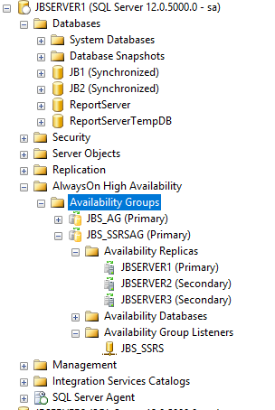
-> Reconfiguring the SQL Server Reporting Services on JBSERVER4 to use the Availability group listener,
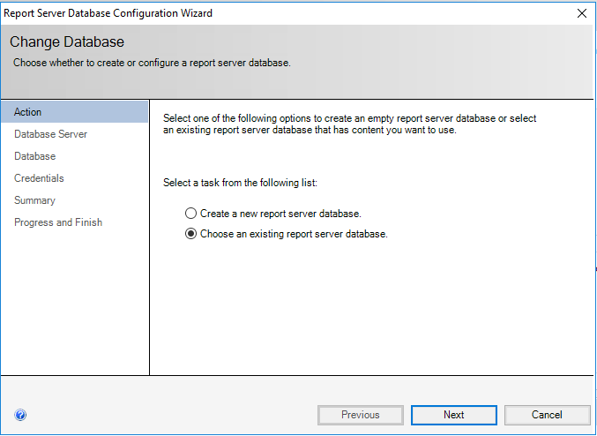
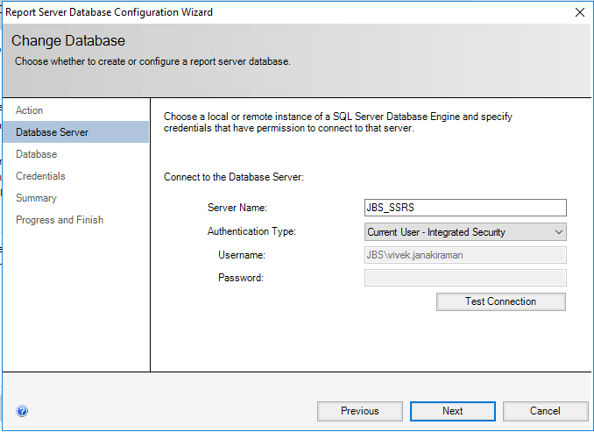
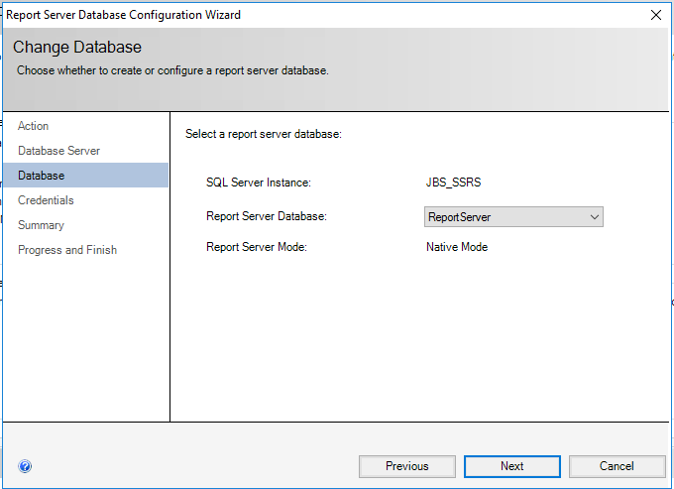
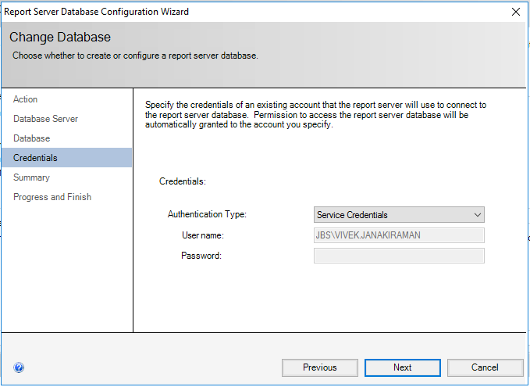
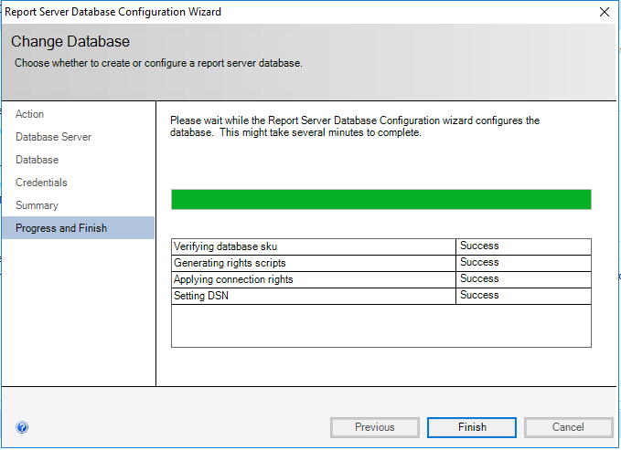
-> Executing a Sample report that uses Availability group Listener JBS_APP that has read-only routing configured.
-> Please refer article “Configuring Read Only Routing List for AlwaysON Availability Group” to get more details on Availability group JBS_AG and its Listener JBS_APP.
-> The data source on the report doesn’t use Application Intent,
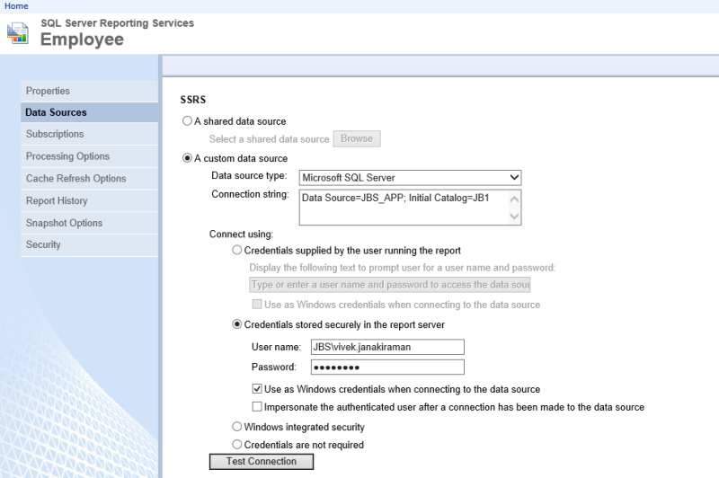
-> Executing the report and checking the profiler trace. The queries are executed on the Primary JBSERVER1.
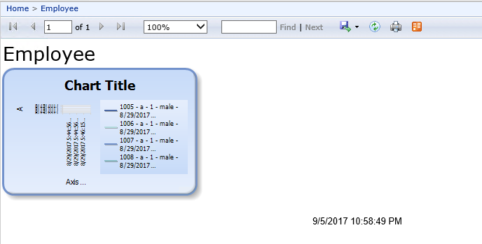
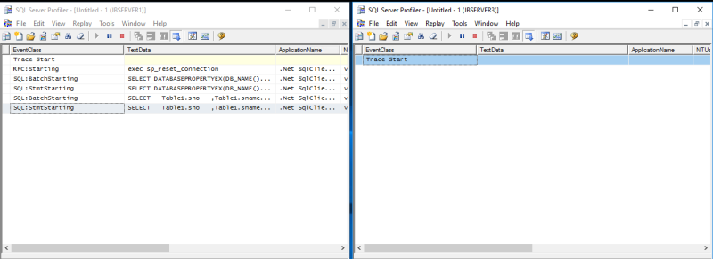
-> The data source on the report uses the Application Intent to ReadOnly,
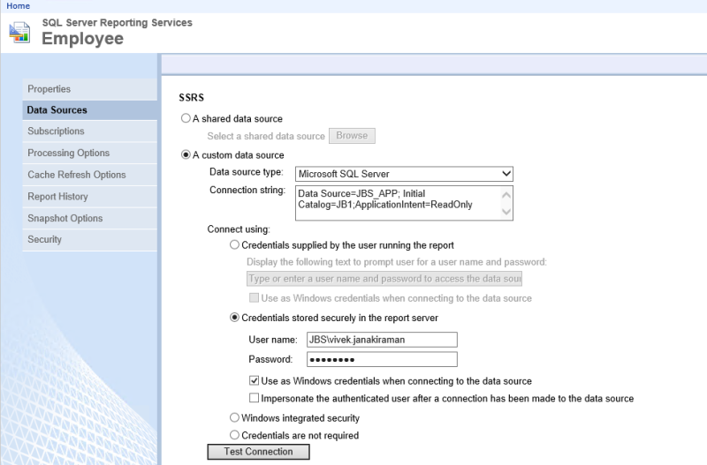
Powered by wordads.co
Seen ad many times
Not relevant
Offensive
Covers content
Broken
REPORT THIS AD
-> Executing the report and checking the profiler trace. The queries are executed on the Secondary JBSERVER3.
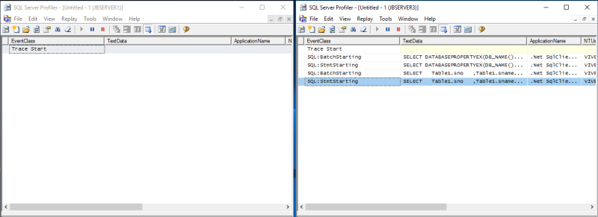
SQL Server Reporting Services Subscription Jobs
-> Execute the below query only once on database server JBSERVER1, JBSERVER2 and JBSERVER3. The table stores the details whether that particular replica is a primary or secondary replica.
create table AG_role (Role int)
insert into Ag_Role select sys.fn_hadr_is_primary_replica(N'ReportServer')

-> Save the below script as a powershell script file on Server JBSERVER1, JBSERVER2 and JBSERVER3. Please make sure that $AGReplica is changed appropriately in the script on each of the server before saving.

$AGReplica = "JBSERVER1";
$AG_ROLE_Previous = Invoke-Sqlcmd "select * from AG_role;" -ServerInstance $AGReplica;
$AG_ROLE_Current = Invoke-Sqlcmd "select sys.fn_hadr_is_primary_replica(N'ReportServer') as Role;" -ServerInstance $AGReplica;
If ($AG_ROLE_Previous.Role -eq $AG_ROLE_Current.Role)
{
"No Failover occurred"
}
else
{
"Failover occurred"
#Delete the SQL Server agent jobs related to Subscription</h6>
Invoke-Sqlcmd "DECLARE @TSQL NVARCHAR(MAX) = N'';
SELECT
@TSQL = @TSQL + 'EXEC msdb.dbo.sp_delete_job @job_name = N''' + j.name + '''' + CHAR(13)
FROM msdb.dbo.sysjobs AS j
JOIN msdb.dbo.syscategories AS c
ON j.category_id = c.category_id
WHERE c.name = N'Report Server';
EXEC sp_executesql @TSQL;" -ServerInstance $AGReplica;
If ($AG_ROLE_Current.Role -eq 1)
{
"Failover Occurred"
$SSRSServers = Invoke-Sqlcmd "If (SELECT sys.fn_hadr_is_primary_replica(N'ReportServer')) = 1 SELECT MachineName FROM [ReportServer].[dbo].[Keys] WHERE MachineName IS NOT NULL" -ServerInstance $AGReplica;
Foreach ($SSRS in $SSRSServers)
{
Get-Service -Name "ReportServer" -ComputerName $SSRS.MachineName | Restart-Service;
}
}
}
Invoke-Sqlcmd "delete from AG_Role;" -ServerInstance $AGReplica;
Invoke-Sqlcmd "insert into AG_Role SELECT sys.fn_hadr_is_primary_replica(N'ReportServer');" -ServerInstance $AGReplica;

->On the Secondary replica, the script basically deletes all the jobs related to SSRS subscription in the SQL Server Agent when it detects a failover.
->On the primary replica, the script deletes all the jobs related to SSRS subscription in the SQL Server Agent and restarts the SQL Server Reporting Services on JBSERVER4 if it detects a failover. This ensures that the subscription jobs are recreated on the primary replica.
-> Create a SQL Server agent job to call the Powershell script saved in the previous step under a job step with type PowerShell. The job should run every 1 minute and also when the SQL Server Agent starts.

